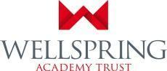

Do you want a job where you make a difference to the lives of children and young people?
Do you want to be inspired on a daily basis by your work?
Scale 4 Teaching Assistants - North site
SCALE 4 TA (Point 7-11) TEACHING ASSISTANTS – 37 HOURS (TTO + 5) FTE SALARY £20,092 TO £21,748 (ACTUAL SALARY £17,242 - £18,664)

-------------------------------------------------------------------------------------------------
Springwell Leeds is a one of a kind, multi-site, city-wide specialist provision for children with SEMH needs. Exciting opportunities are available for people looking for a fresh challenge in an inspiring learning environment where we provide children aged 5-16 with specialist teaching and learning. The posts will suit candidates who have the commitment, passion and resilience to make a difference to pupils who have a range of social, emotional, mental health and special educational needs.

What We Are About…

Relationships. Unconditional Positive Regard. Trauma-informed Practice. Restorative Practice. Continuous Professional Development. Pupil-focussed, Needs-focused

What Our Staff Say…

‘No two days are the same!’
‘I enjoy working with the most vulnerable children, as I feel like I am really making a difference’
‘We are like a family here’
‘The job is rewarding and fun. You will build amazing relationships with students, staff and parents.’
‘There are opportunities to progress onto other roles within Springwell.’
‘I love being a part of a wonderful team who are so resilient and caring.’

What Our Children Say…

‘We have an amazing massive building with loads of different children.’
‘The staff help me manage my emotions and regulate.’
‘The teachers find things we love and do them with us.’
‘They teach us new things like how to tie our shoelaces.’
‘We know the adults have our backs.’
‘Adults know when we are mad and know how to help us calm down.’

Our unique position as an SEMH through-school means we are able to have a long-term and lasting impact on the children in our care. We aim to be the ‘forever school’ for children who come to us for their education. We are a trauma-informed school, and staff use this expert knowledge in their daily work. We believe in the power of unconditional positive regard and restorative practice and incorporate this in everything we do. These approaches work hand in hand with a nurturing curriculum to give our students secure foundations rooted in relationships. Working at Springwell offers challenge and reward in equal measures, as we work together to regulate students with varying levels of SEMH need, allowing them to access learning.

These posts are for staff who will support students with SEMH and academic learning within the classroom as part of a team of 3 staff with up to 9 students. Teaching Assistants are responsible for supporting and leading small groups and individuals with Maths, English, reading, SEAL, practical activities, supporting pupils to develop resilience, social skills and self-esteem, and deploying effective strategies for supporting pupils with a range of behavioural conditions (ASD/ADHD/SEMH/ODD). They support the teacher in the production of classroom and specialist resources, and so a good working knowledge of ICT is essential.

As part of the Wellspring Academy Trust, we have access to a network of Expert Practitioners, our own teaching school, and a brand new CPD TV channel; we are well equipped to support career development at all levels, including routes into teaching.

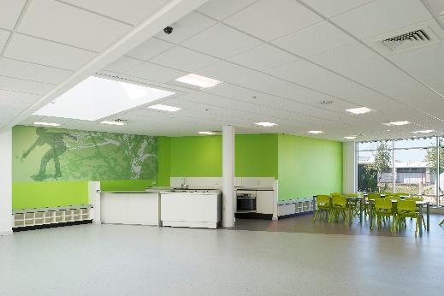
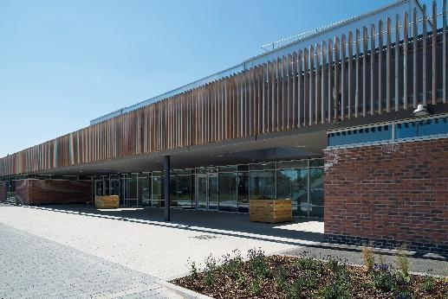

About us
Our aim is to provide the best possible care and education that we can for children and young people with Social, Emotional and Mental Health (SEMH) needs. Unconditional Positive Regard is at the centre of what we do and we are creating an academy that is welcoming, caring, safe, warm and believes that all its pupils can be supported and empowered to succeed. We take pride in creating individual and personalised pathways for our students that are built around their varied needs, which will help them achieve positive outcomes and prepare them for their onward destinations into continuing education, work or training. In order to achieve this, we have developed a curriculum that provides opportunities for academic progression as well as vocational learning, whilst being engaging, creative, and innovative.
We see strong relationships as the key to our success – with students, parents, carers and the wider community and we ensure that our academy is a welcoming safe place for children, and staff, to learn and prosper. We believe in working closely with our families and carers and welcome their support, but also realise that at times they will need our support too. We work closely with other agencies and schools to make sure we do all we can to make learning and life the best it possibly can be.
Here at Springwell, we place a huge emphasis on professional development and choose to invest significantly in staff training at all levels. This means that, although experience of working in an SEMH setting would be an advantage, specialist support and training will be provided for outstanding applicants wishing to make the career fulfilling move into special education.
To find out more about what makes us special and our ethos, please visit our website at www.springacademyleeds.org and follow us at @Springwell_Lds to see what our staff and amazing young people get up to on a daily basis.
-----------------------------------------------------------------------------------------------------------------------------------------------
If you would like to discuss or find out more about this post, please contact Nichol Pace, n.pace@springwellacademyleeds.org. This post closes at 09.00hrs Friday 14th January 2022.
To apply, you will need to complete a Springwell Academy Leeds application form which then needs to be e-mailed to Nichol Pace at n.pace@springwellacademyleeds.org stating any preference in Springwell Leeds Academy site.
All applicants should complete the Equal Opportunities form. Please click link for further details http://bit.ly/WATEqualOpportunities
Springwell Leeds is committed to safeguarding and promoting the welfare of children and young people and expects all staff to share this commitment. All shortlisted candidates will be required to complete a self-disclosure form. The amendments to the Rehabilitation of Offenders Act 1974 (Exceptions) Order 1975 (2013 and 2020) provides that when applying for certain jobs and activities, certain convictions and cautions are considered ‘protected’. This means that they do not need to be disclosed to employers, and if they are disclosed, employers cannot take them into account. Guidance about whether a conviction or caution should be disclosed can be found on the Ministry of Justice website. Successful candidates will also be required to undergo an enhanced disclosure and barring services check.
www.springwellacademyleeds.org
www.wellspringacademytrust.co.uk

